**Task 6**

**Step 1: online_sales (orders table with order_date, amount, product_id)**

* create table online_sales(order_id int primary key,order_date date not null,amount decimal(10,2),product_id int);
* desc online_sales;
* INSERT INTO online_sales VALUES(1,'2025-04-01', 199.99, 101),(2,'2025-04-02', 49.50, 102),(3,'2025-04-03', 89.00, 103),(4,'2025-04-03', 25.00, 101),(5,'2025-04-04', 300.00, 104),(6,'2025-04-04', 75.00, 102);
* Select * from online_sales

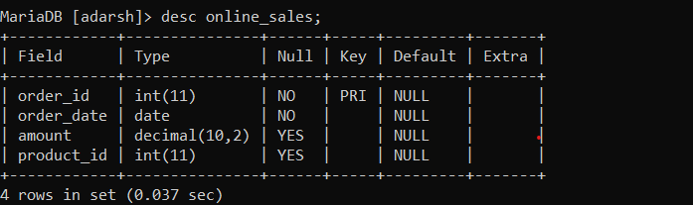

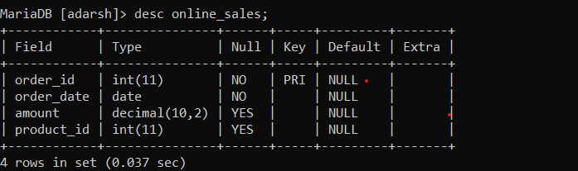

**Step2:** Use EXTRACT(MONTH FROM order_date) for month

* SELECT order_id,order_date,EXTRACT(MONTH FROM order_date) AS order_month,amount,product_id FROM online_sales;

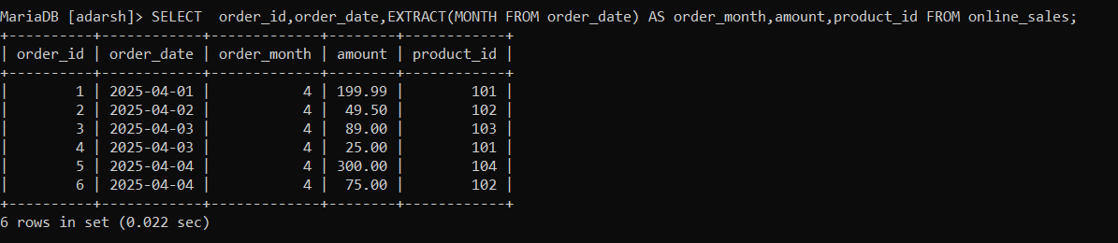

Step 3:

* GROUP BY year/month.
* Use SUM() for revenue.
* COUNT(DISTINCT order_id) for volume.
* Use ORDER BY for sorting

SELECT EXTRACT(YEAR FROM order_date) AS order_year,EXTRACT(MONTH FROM order_date) AS order_month,SUM(amount) AS revenue,COUNT(DISTINCT order_id) AS volume FROM online_sales GROUP BY EXTRACT(YEAR FROM order_date),EXTRACT(MONTH FROM order_date) ORDER BY order_year,order_month;

